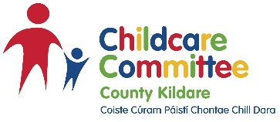
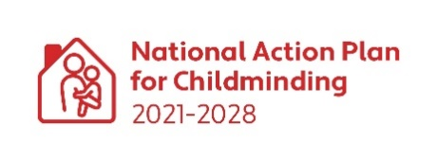
Childminding Development Grant Expenditure Report
The Childminding Development Grant is paid 75% in advance and up to 25% in arrears. To receive the final maximum 25%, you must have spent, reported on, and provided receipts* for 100% of your total grant awarded or the amount you required if less than the grant awarded. All receipts submitted as proof of expenditure must be for eligible items. All receipts must be dated between Monday 22 July 2024 and the expenditure closing date of Friday 4 October 2024.

The receipts must be emailed/posted with this completed and signed CMDG Expenditure Report to your local CCC before the deadline of Friday 18 October 2024. However, you can submit this report and receipts as soon as you have spent the full grant awarded.

Your expenditure report and receipts will be checked in line with the procedures set out in the guidelines.

For new/potential childminders you must have started your childminding service by 18 October 2024 and include a copy of your in date childminding insurance with your expenditure report.

*Receipts: Invoices and/or quotations are not sufficient for proof of expenditure. It must be by itemised receipt only. Please note: Receipts dated outside of the expenditure time will not be accepted and expenditure will be deemed ineligible. This may affect your grant payments. Copies of receipts must be clear and easy to read.

Childminding Development Grant 2024 Expenditure Form

Name of CCC
Name of Applicant
Address of Applicant
Mobile Telephone
E-mail
Grant amount awarded
Amount spent
Balance to be paid to applicant
(If applicable)
Amount to be returned by applicant (If applicable)

All expenditure should be listed per section with all accompanying receipts

 | Area of spend | Amount spent
1 | Outdoor Area
2 | Risky Play
3 | Gardening Area
4 | Toys/Books
5 | Childcare & Safety Equipment
6 | Supporting Inclusion
7 | IT equipment
8 | STEAM Equipment (Science/Technology/Engineering/Arts/Maths)

By ticking this box, I declare I have spent the full amount of the grant awarded to me ☐
or
By ticking this box, I declare I have not spent the full amount of the grant awarded to me and I will return any unspent grant funding to (Insert CCC Details) _______________County Childcare Committee before the 29^{th of} November 2024 ☐

By signing this form, I am declaring that I spent the grant according to the terms and conditions set out in the application form, that the receipts I have provided relate to expenditure allowed under the grant, that the receipts show the full cost of each item, and that no other Government grants or funds were used to purchase the items.

Applicant Signature: _____________________________________________

Date: _____________________________________

Please post/email your completed and signed CMDG Expenditure Report and include all receipts for the full value of your grant awarded to:

Barbara Alessandrini
Childminding Development Officer
Kildare County Childcare Committee
Unit 21
Thompson Enterprise Centre
Clane Business Park
Clane
Co. Kildare
W91E6NY

